OTT Platform Analytics - Entertainment Sector
Pooja Joshi & E25007

Overview :
In today’s analysis, the focus was on understanding various performance metrics and trends within the OTT platform, specifically for movies and series. The goal was to extract actionable insights that can guide decision-making regarding content strategy, audience targeting, and platform growth.

Objective :
The main objective of this task was to analyze key performance indicators (KPIs) of the OTT platform's content to identify popular titles, top-rated content, language distribution, and viewership trends. This analysis will help the platform refine its content strategy and better cater to its audience.

Assigned Task(s)

- Analyze the dataset to extract insights related to content popularity, audience engagement, and distribution of language and media types (movies/series).
- Create visualizations for language distribution, content breakdown (movies vs series), and adult content analysis.

Task Details
Task 1: OTT Platform Content Popularity and Rating Analysis
Status: Completed
Details: The dataset was loaded and cleaned for analysis. Key metrics such as the most popular titles and the top-rated titles were calculated using the popularity and vote_average fields, respectively.

Task 2: Language Distribution and Content Type BreakdownStatus: CompletedDetails: We visualized the language distribution of the platform’s content and analyzed the share of movies versus series using a pie chart.

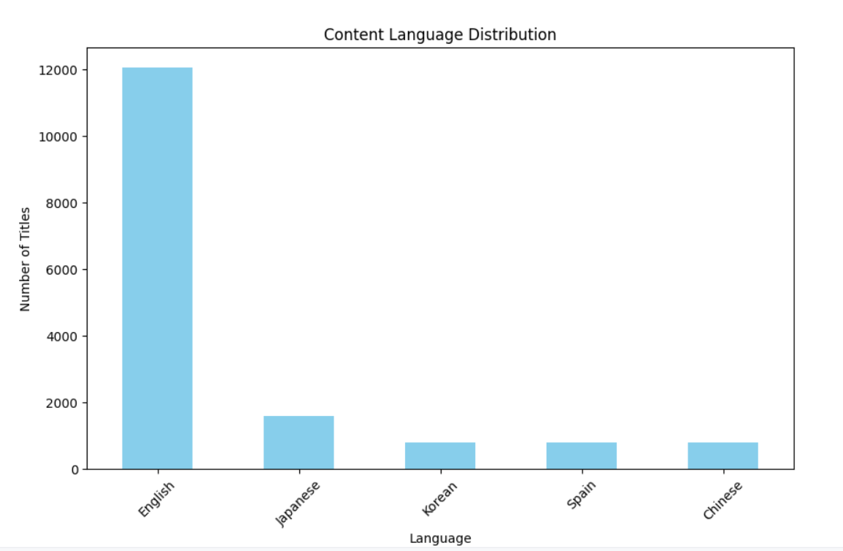

Task 3: Adult Content Analysis and Viewership InsightsStatus: CompletedDetails: Adult and non-adult content breakdown was visualized, and the titles with the highest attendance count were identified for further analysis.

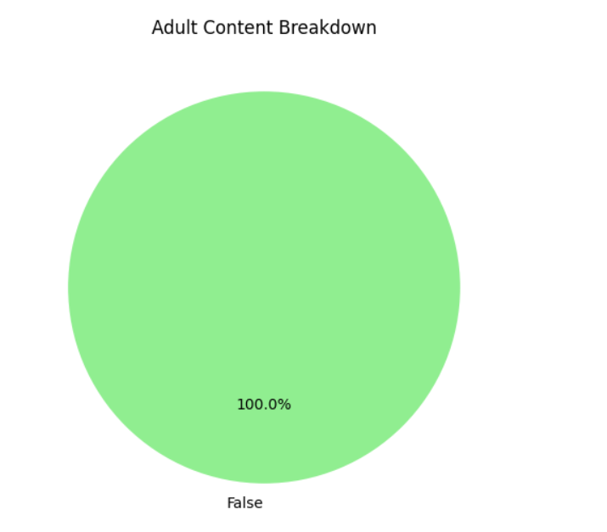

Progress :

Accomplishments:
- Successfully analyzed and visualized the top 10 most popular and top 10 highest-rated titles.
- Identified the distribution of content by language and content type (movies vs series) with appropriate visualizations.
- Analyzed the proportion of adult vs non-adult content on the platform.

Metrics:
- Top 10 Most Popular Titles: Extracted based on popularity score.
- Top 10 Highest Rated Titles: Identified using vote_average values.
- Language Distribution: The most common languages were found to be English, Hindi, and Spanish.
.

Challenges and Solutions

Challenges Faced:Initial difficulty in loading the dataset due to file format issues (incorrect engine specified for reading Excel).Solutions Implemented:Replaced the read_excel function with read_csv to correctly load the data from a .csv file, allowing smooth analysis.

Next Steps

Upcoming Tasks:
- Explore regional or demographic insights if additional data is available.
- Perform deeper analysis of user engagement metrics such as retention rates or time spent on platform content.
[TNR-12]

Goals:
- Refine the content recommendation model by incorporating viewer preferences from different regions and languages.
.

Conclusion

Summary: Today's analysis provided insights into the most popular and highest-rated titles, the distribution of content by language, and the balance between adult and non-adult content. These findings will be valuable in optimizing content strategies for the OTT platform moving forward.

- Acknowledgments: Thank the audience for their time and attention.

Instructions:
- Use Google Docs. Single Column
- TNR stands for Times New Roman: B - Bold
- Use images as required with proper references
- Use charts, tables as per your requirement.
- Number of Pages: 2 to 8 for each task report.

